- Pre Wrap | 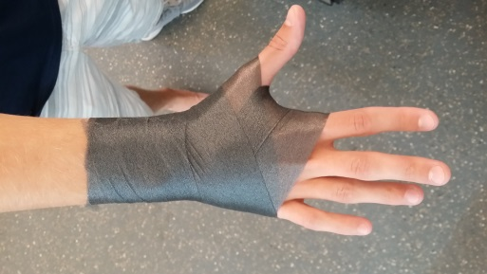 | Start the pre wrap about an inch below the wrist and overlap it as you make your way up and around the hand.
- Cover Strips | 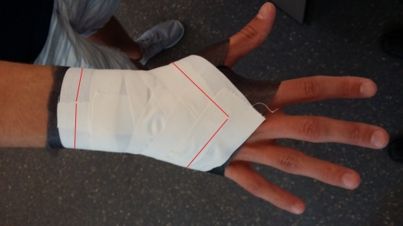 | Starting at the distal ends of the ulna and radius, overlap each strip at least halfway. Once you reach the hand, start angling the strips to make a point towards the 3rd phalange
- Figure 8’s | 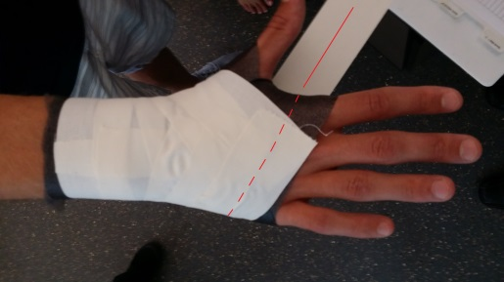 | Start on the volar aspect of the hand on the 5th metacarpal and direct the tape towards the area between the 1st and 2nd phalanges
3b. Figure 8 Pinch | 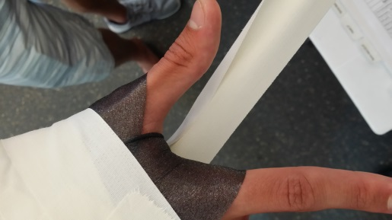 | Before bringing the tape around the hand, pinch the tape on the thumb side to help prevent tape cuts
3c. Figure 8 | 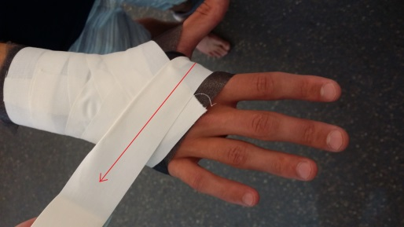 | Continue the tape around the top of the hand and around the underside of the wrist
3d. Figure 8 Finish | 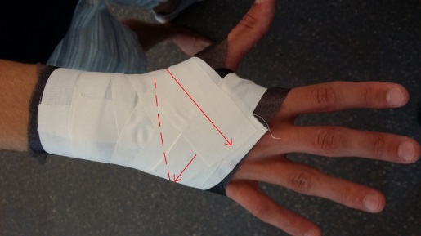 | Finish the figure 8 by bringing it around the wrist and ending on the top of the hand
- Closing Strips | 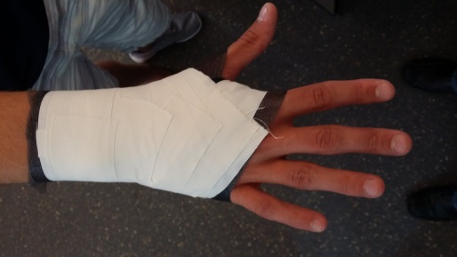 | Finish taping by applying individual closing strips (just like the cover strips, but in reverse) starting on the top of the hand and ending around the ulna and radius

