- Pre Wrap | 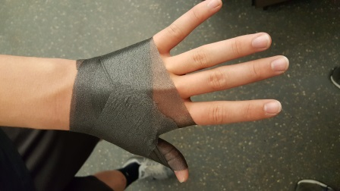 | Start the pre wrap on the back of the hand and wrap it around the hand and thumb
- Anchor Strips | 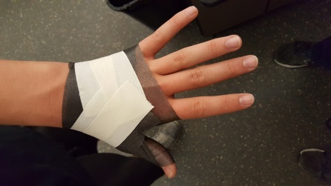 | Place two anchor strips over the back of the hand with the ends pointing towards the middle finger
- Thumb Strips | 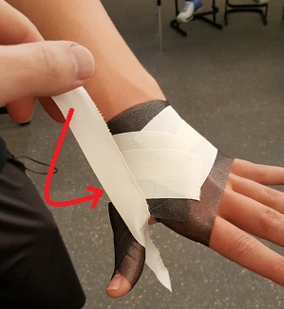 | Measure out a strip of tape, ~10” long, and tear it into two narrow strips.  Place the halfway point of the tape on the inside of the thumb and.  Take the top end and bring it down under the hand, making sure that it attaches to the anchor.
3b. Thumb Strips | 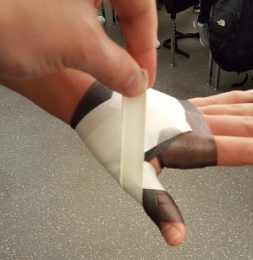 | With the bottom end, bring it up and around the thumb, ending on the back of the hand.  Repeat these two steps with the other narrow strip.
5. Closing Anchor | 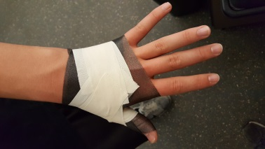 | End the taping by placing a closing anchor over the starting anchors

