Splinting Techniques
Wrist: Ulna/Radius Fracture
Step 1: Fold a 36-inch SAM Splint in half upon itself.
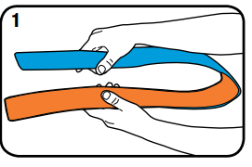
Step 2: Roll the end over to provide more comfort for the fingers.
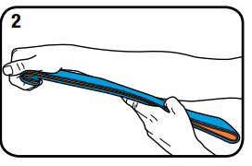
Step 3: Add strength by creating a C-Curve
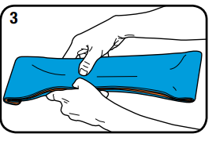
Step 4: Using your own right or left arm as a template, mold the splint to the general shape of the wrist and forearm.
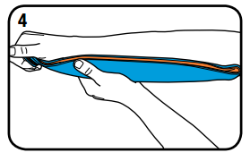
Step 5: Make adjustments to fit the injury and apply to the patient. Only small adjustments should be made once the splint is in place. Secure with your wrap of choice.
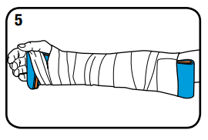

Humerus Fracture
Step 1: Fold one third of a 36-inch SAM Splint upon itself to create a 12-inch section of double-layered splint.
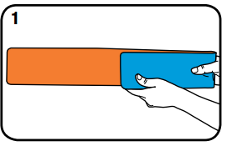
Step 2: Curve the double layer into a fishhook shape and secure the double layer with your wrap of choice.
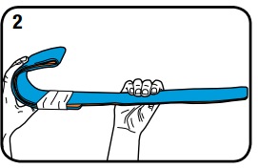
Step 3: Form a C-Curve along the shank of the fishhook for strength and fit.
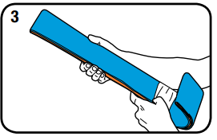
Step 4: Apply the splint to the patient. Fold any excess splint over the patient’s shoulder or back upon itself.
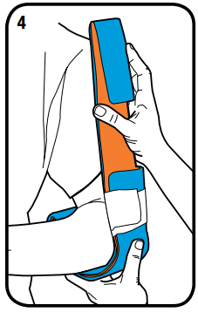

Step 5: Secure with your wrap of choice. Apply a sling and swath for additional support.
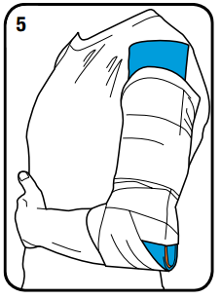
Fibula Fracture
Step 1: Fold a 36-inch SAM Splint to create two equal halves.
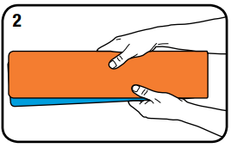
Step 2: Apply C-Curves twothirds of the distance down each half. Add Reverse C-Curves on the edges if needed for strength. Do not extend the curves further or they will stiffen the splint and limit your ability to fold it around the foot and ankle.
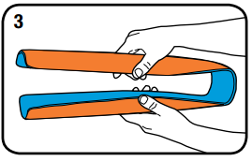
Step 3: Fold the stirrup splint around the foot and ankle.
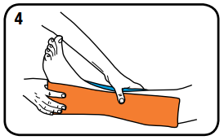
Step 4: Secure with your wrap of choice.
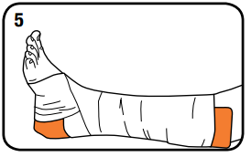
Shoulder Dislocation
Step 1: Fold the outer sections along the longitudinal axis, leaving the middle section flat. Hook the outer folded ends together, producing a triangle. A more rounded, gentler curve or half-circle is then folded along the longitudinal axis of the flat section of the triangle. This curve is formed to contour to the shape of the arm
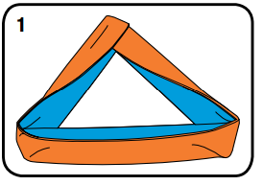
Step 2: The triangle is then placed in the axilla and used to support the abducted arm. The arm triangle is held in place by the patient or secured to the patient’s trunk with your wrap of choice.
