Special Tests for the Spine
Brachial Plexus Test
- Injury/structure tested: Cervical Spine (Brachial plexus) for compression and traction injuries
- Patient position: patient should be sitting straight up
- Hand placement: One hand on the patient’s shoulder, the other hand on the side of the skull, positioned slightly above the ear
- Action: Lateral flexion or bending of the cervical spine by the application of pressure on both the head and the shoulder duplicates the mechanism of injury to the brachial plexus.
- Positive sign: If the cervical spine is flexed to the right and pain radiates to the right shoulder and arm, a compression injury exists. If the pain radiates to the left shoulder and arm, a traction or stretch injury has occurred.

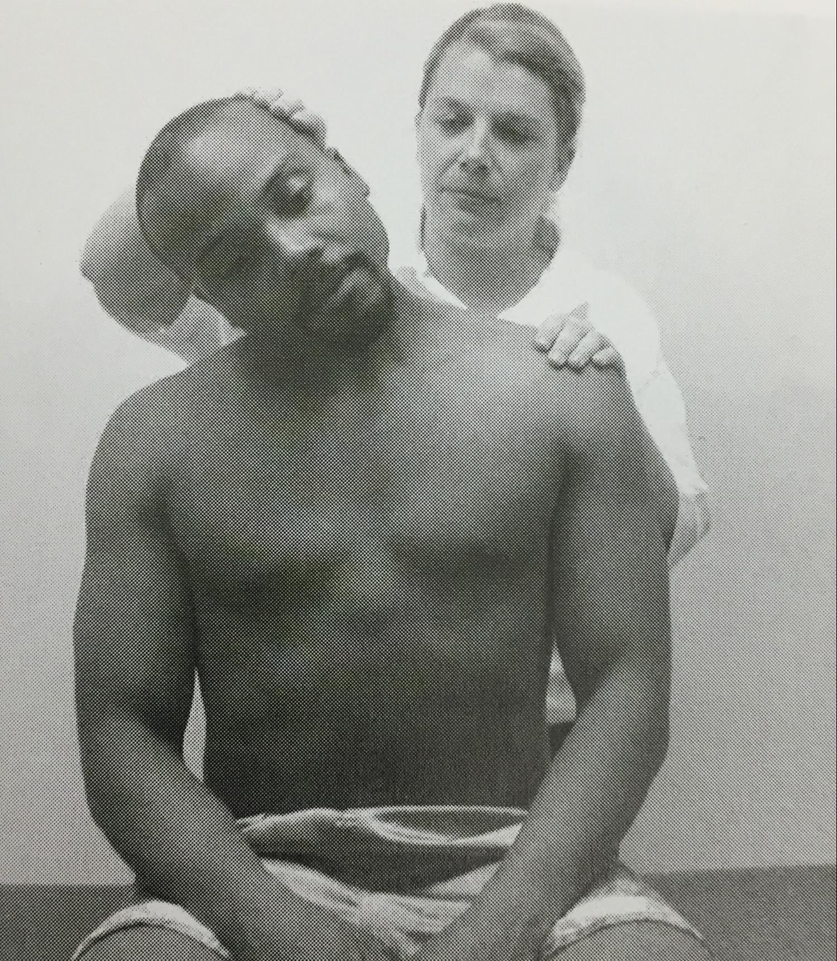

Cervical Compression Test
- Injury/structure tested: Cervical spine (impingement of cervical spinal nerve roots)
- Patient position: sitting up straight
- Hand placement: Hands folded together and placed on top of patient’s head
- Action: A downward force on top of the patient’s head
- Positive sign: Pain radiating to the arm

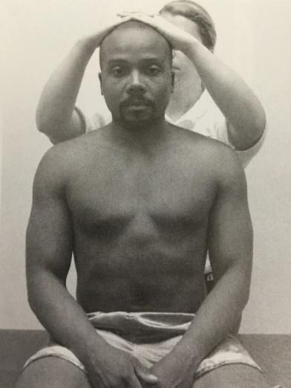

Spurling’s Test
- Injury/structure tested: Cervical Spine (impingement of cervical spinal nerve roots)
- Patient position: sitting up straight with lateral bend and slight extension of the neck
- Hand position: hands folded together and placed on top of the patient’s head
- Action: downward force on top of the patient’s head
- Positive sign: Pain in the shoulder and arm on the side of flexion = compressed nerve; Pain felt on opposite side = muscle spasm

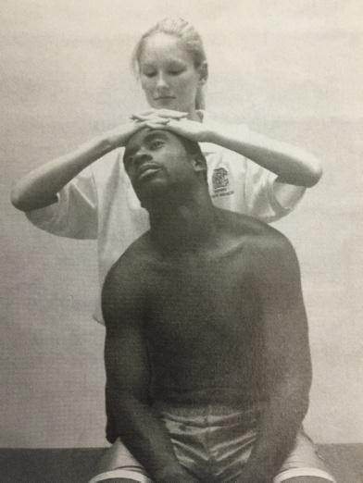

Shoulder Abduction Test
- Injury/structure tested: Cervical Spine (Cervical disc herniation)
- Patient position: sitting down
- Hand placement: the athlete abducts the shoulder by placing the hand on top of the head
- Action: no force or any movement
- Positive sign: arm pain goes away or a decrease in symptoms

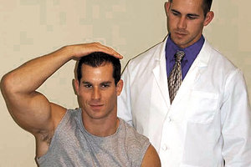

Vertebral Artery Test
- Injury/structure tested: This is testing for compression of vertebral artery.
- Patient position: The athlete is supine (lying on their back).
- Hand placement: The tester’s hands are on the back of the head.
- Action: The tester extends, then laterally bends and rotates the cervical spine in the same direction and holds it there for 30 seconds
- Positive Sign: Positive sign is dizziness or abnormal movement of eyes.

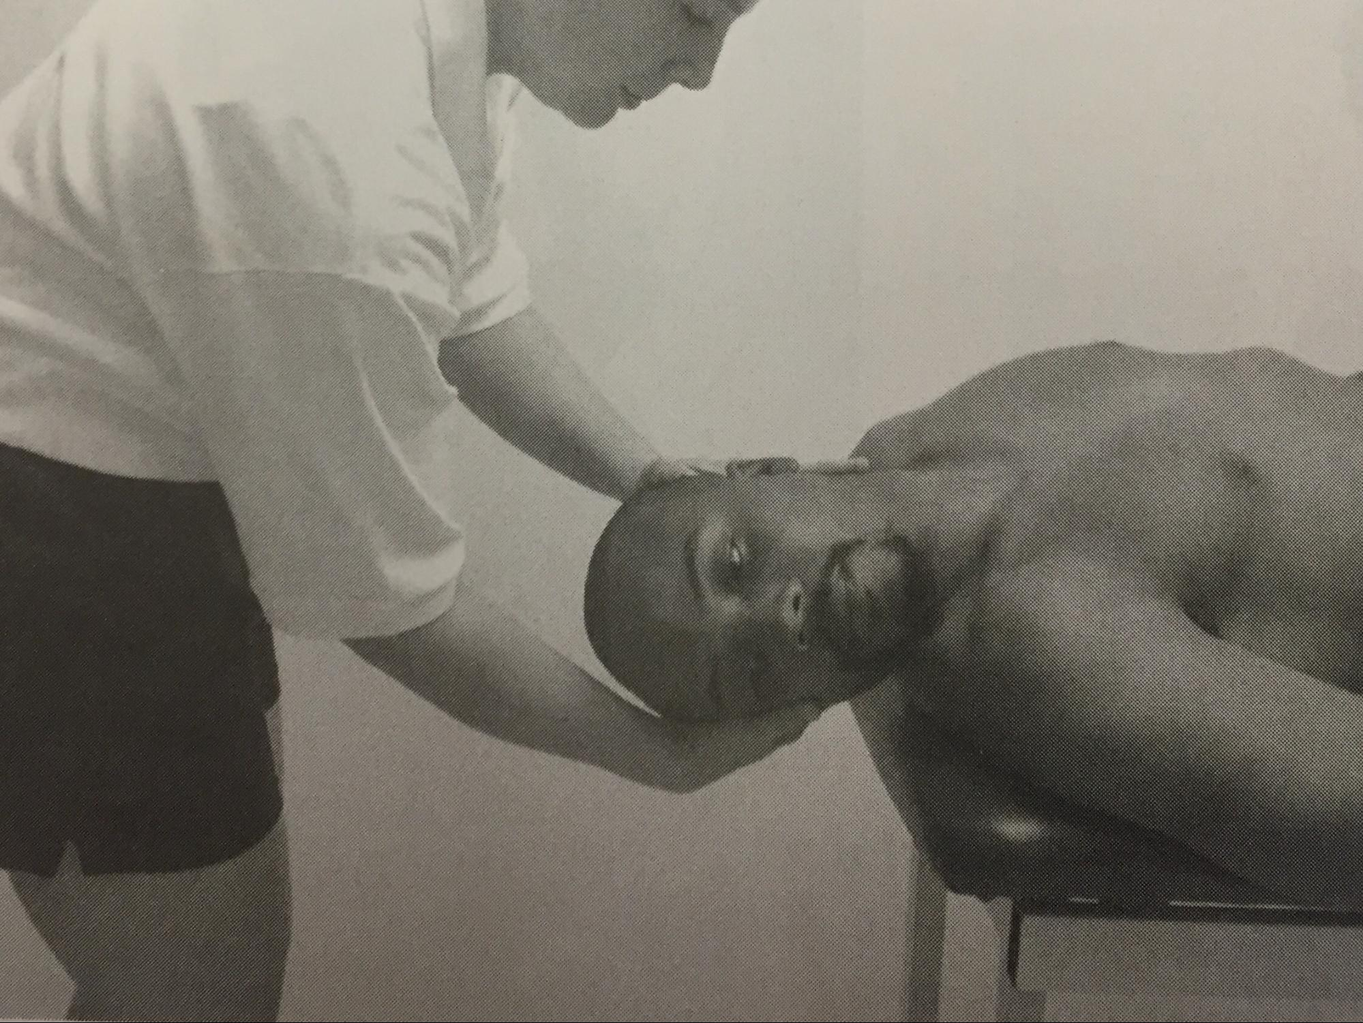

Slump Test
- Injury/Structure tested: Lateral disk Herniation, nerve root adhesions, or vertebral impingement
- Patient Position: The athlete sits with knees flexed and feet on the ground
- Hand Placement: Place one hand on the back of the athletes head, and the other hand on the posterior side of the athlete’s knee
- Action: The thoracic and lumbar spines begin flexed with overpressure and pain should be assessed in this starting position, then reassess pain after each of the following steps
1. Sitting with shoulders slumped forward and head up straight
2. The cervical spine is flexed
3. One knee is extended
4. The ankle is dorsiflexed
5. Both legs are extended simultaneously
- Positive sign: Increase in Pain

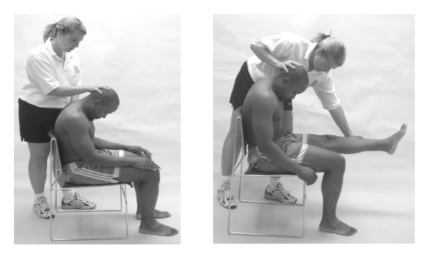

Bowstring Test
- Injury/structure tested: This is testing for sciatic nerve irritation.
- Patient position: The athlete is supine (lying down). The tester’s hand is on the popliteal fossa (knee pit).
- Action: The leg on the affected side is lifted until pain is felt. The knee is then flexed until pain is relived, then pressure is applied to the popliteal fossa (knee pit).
- Positive sign: A positive sign is pain felt during palpation along the sciatic nerve.

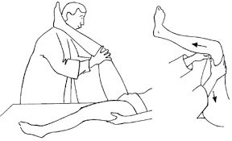

Brudzinski’s Test
- Injury/structure tested: Lumbar disk or some nerve root irritation
- Patient position: Lying supine on a table
- Hand placement: Standing on the affected side with one hand on the back of their head/neck
- Action: Flex their chin towards their chest
- Positive sign: Their hip and knee flex to relieve their pain

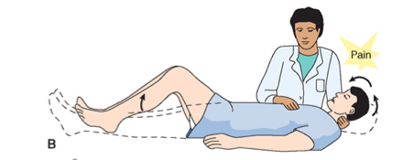

Kernig’s Test
- Injury/structure tested: Impingement of nerve root due to bulging disc or bony entrapment
- Patient position: Lying supine
- Hand placement: One hand on their knee, the other on their ankle
- Action: Flex their hip & knee to 90° and then slowly extend their leg, keeping the hip at 90°
- Positive sign: Pain in their lower back, neck, and/or head

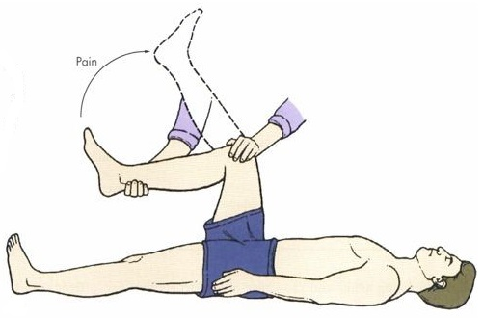

FADIR Test
- Injury/structure tested: Indicates a problem in the lumbar area
- Patient position: Patient should be lying in Supine position
- Hand placement: Place one hand on their knee and the other around their foot/ankle
- Action: Flex their hip and knee to 90°, Adduct their hip, and Internally Rotate by pulling their foot laterally.
- Positive sign: Pain in their SI joint area

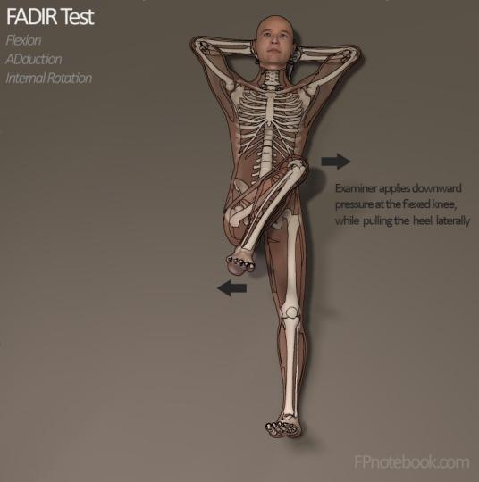

Milgram Test
- Injury/structure tested: Indicates a problem in the Lumbar Spine
- Patient position: Athlete should be lying in a supine position with their legs fully extended and slightly raised off the table.
- Hand placement: Support the heels of the athletes until they have raised their legs.
- Action: Have the athlete fully extend their legs and raise them about 6-8 inches off the table for thirty seconds.
- Positive sign: Inability to hold both legs off the treatment table for thirty seconds

Hoover Test
- Injury/structure tested: This is a test for malingering (faking an injury)
- Patient position: Athlete should lay in a supine position with both legs fully extended and raised slightly off the table
- Hand placement: Examiner at the feet of the athlete with hands cupping the calcaneus of each leg.
- Action: Athlete attempts to actively straight leg raise on the involved side
- Positive sign: No downward pressure is felt in the opposite foot

Well Straight leg Raising Test
- Injury/structure tested: Nerve root inflammation
- Patient position: Lying supine
- Hand placement: On the unaffected side, lift the leg upwards
- Action: Lift their leg straight up, keeping their knee fully extended, then dorsiflex their foot
- Positive sign: Pain in the lower back on the affected side as well as pain radiating along the sciatic nerve

