Special Tests of the Knee

Valgus Stress Test
- Performed to evaluate an injury to the MCL
- Have the athlete lay supine (on their back) with their leg extended
- Hold their ankle with one hand and place your other hand on the lateral side of their knee, over the head of the fibula
- Apply a force inward in an attempt to open up the medial side of the knee
- Perform this maneuver with their leg fully extended and also at 30° of knee flexion
  - At 30° the MCL is isolated
- A positive sign is excess laxity (movement) compared to the uninjured side

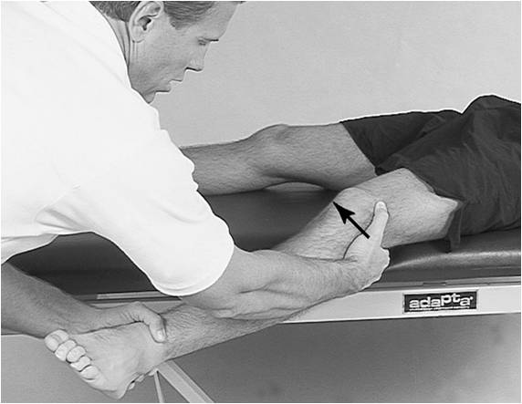

Varus Stress Test
- Performed to evaluate an injury to the LCL
- Have the athlete lay supine (on their back) with their leg extended
- Hold their ankle with one hand and place your other hand on the medal side of their knee
- Apply a force outward in an attempt to open up the lateral side of the knee
- Perform this maneuver with their leg fully extended and also at 30° of knee flexion
  - At 30° the LCL is isolated
- A positive sign is excess laxity (movement) compared to the uninjured side

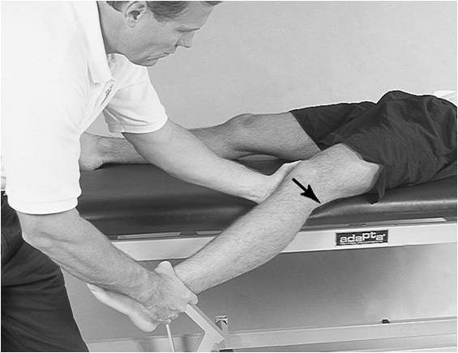
Anterior Drawer Test
- Performed to evaluate an injury to the ACL
- Have the athlete lay supine on a table with their injured leg flexed to 90°
- Sit on their toes to stabilize their foot
- Place both hands around the upper portion of their tibia with your fingers behind their leg and your thumbs on the medial and lateral joint lines
- Pull their tibia forward
- A positive sign is excess laxity (movement) compared to the uninjured side

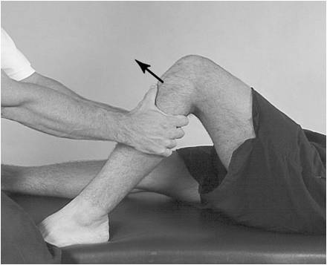

Lachman Test
- Performed to evaluate an injury to the ACL
- Have the athlete lay supine on a table
- Use one hand to stabilize the distal end of the thigh, and grasp the proximal end of the tibia with the other
- Pull the tibia anteriorly
- A positive sign is excess laxity (movement) compared to the uninjured side

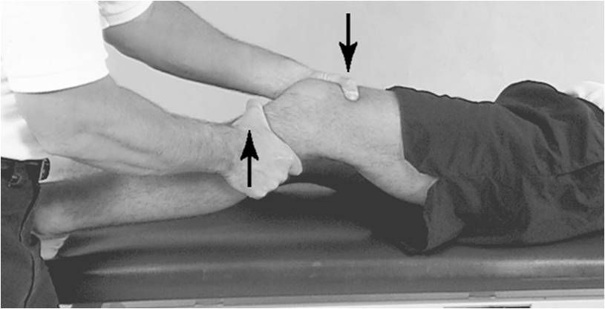
Posterior Drawer Test
- Performed to evaluate an injury to the PCL
- Have the athlete lay supine on a table with their injured leg flexed to 90°
- Sit on their toes to stabilize their foot
- Place both hands around the upper portion of their tibia with your fingers behind their leg and your thumbs on the medial and lateral joint lines
- Push their tibia backward
- A positive sign is excess laxity (movement) compared to the uninjured side
Posterior Sag Test
- Performed to evaluate an injury to the PCL
- Have the athlete lay supine on a table
- Flex their hips and knees to 90°
- Observe the injured side laterally
- A positive test would show the tibia on the injured side sagging compared to the uninjured side

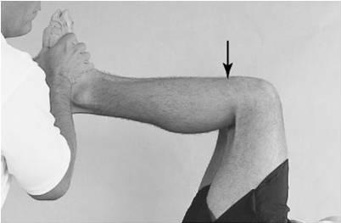

McMurray’s Test
- Performed to determine a meniscus injury
- Have the athlete lay supine on a table with their leg fully flexed
- Place one hand on their foot and the other over the top of their knee
- Internally rotate their foot and extend their leg at the same time
- Reposition their leg into flexion
- Externally rotate their foot and extend their leg at the same time
- The hand on their knee feels for a clicking response
- Medial meniscus tears are felt when the lower leg is externally rotated
- Lateral meniscus tears are felt when the lower leg is internally rotated

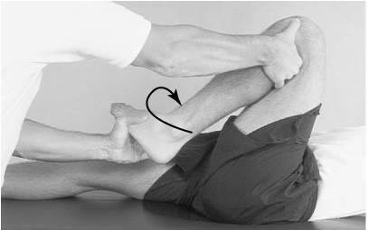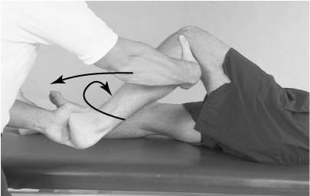
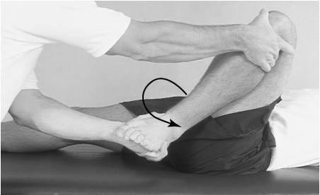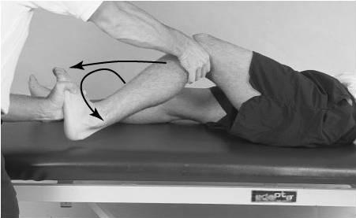

Apley Compression Test
- This test is performed to detect a meniscus injury
- Have the athlete lay prone on a table with their knee flexed to 90°
- Stabilize their thigh and apply a hard downward pressure to the leg
- Rotate their lower leg internally and externally
- Pain would denote an injury to a meniscus
- Medial meniscus tears present pain with external rotation
- Lateral meniscus tears present pain with internal rotation

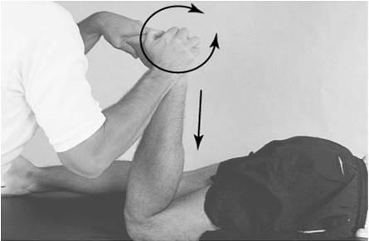

Apley Distraction Test
- This test is performed to distinguish a collateral ligament injury from a meniscal injury
- Have the athlete lay prone on a table with their knee flexed to 90°
- Stabilize their thigh and pull up on their lower leg
- Rotate their leg internally and externally
- Pain will indicate that the injury is to the ligaments
- If a meniscus is torn, no pain will be felt

