Special Tests of the Hip & Pelvis

Kendall Test
- This test is performed to evaluate tightness of the Rectus Femoris muscle or Hip Flexors
- Have the athlete lie supine on a table with the uninjured leg flexed to their chest and their back completely flat against the table
- The injured leg should be flexed at the knee and hanging over the edge of the table
- If the leg cannot stay flat on the table, the test is positive for tight Hip Flexors
- If the lower leg stays flat on the table, but the knee extends more than 70°, the test is positive for a tight Rectus Femoris
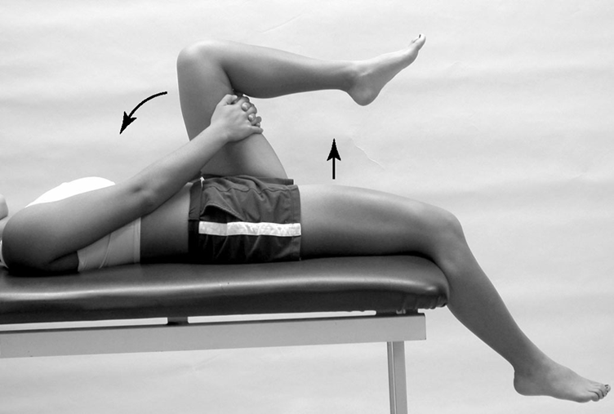

Thomas Test
- This test is performed to indicate if hip contractures are present
- Have the athlete lie supine on a table with their arms folded across their chest, legs together and fully extended
- Place one hand under the athlete’s lumbar curve of their spine
- Bring one thigh to their chest, flattening their spine
- In this position, the other thigh should be flat on the table; if not, the test is positive for a hip contracture
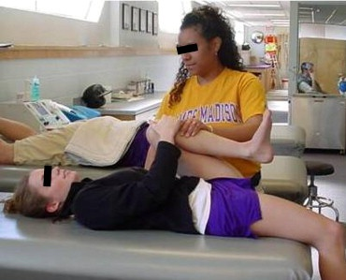
FABER Test
- This test is performed to detect pathological conditions of the hip and sacroiliac joint
- Have the athlete lie supine on a table
- The foot on the side of the painful SI joint is placed on the opposite extended knee (the hip is placed in Flexion, Abduction and External Rotation)
- Apply downward pressure with one hand on the bent knee
- A positive sign would be pain in the hip or SI joint

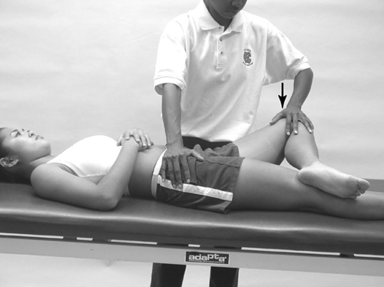

Gaenslen’s Test
- This test is performed to evaluate an injury to the SI joint
- Have the athlete lie supine on a table, with the affected side on the edge of the table
- Flex their unaffected side to their chest
- Apply pressure to their affected side, moving the SI joint into extension
- A positive sign presents an increase in pain with hyperextension

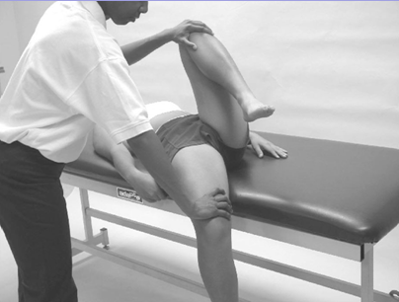

Ober’s Test
- This test is performed to evaluate IT Band tightness
- Have the athlete lie on their unaffected side
- Flex their knee to 90° and abduct their leg as far as possible
- Stabilize their pelvis with your other hand and then release their leg
- This test is positive for IT Band tightness if their leg stays in an abducted position

Nobel’s Test
- This test is performed to evaluate tightness of the IT Band
- Have the athlete lie supine on a table
- Flex their hip and knee to 90°
- Apply pressure to their lateral femoral condyle while they gradually extend their knee
- A positive sign would be pain felt over the lateral femoral condyle with the knee at 30° of flexion

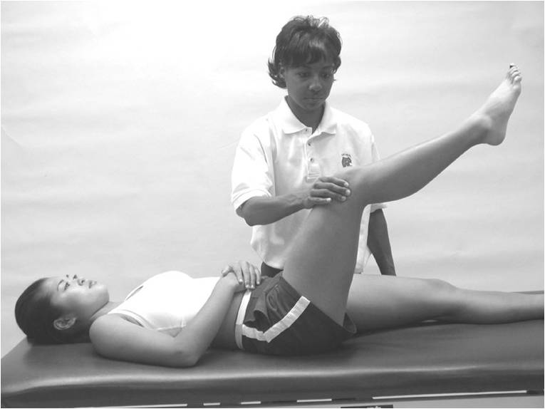

Trendelenburg’s Test
- This test is performed to evaluate weakness in the Hip Abductors, particularly the Gluteus Medius
- Have the athlete stand with their hands on their hips
- Have the athlete lift the foot on their unaffected side
- Normally, the iliac crest on the unaffected side would be higher than on the affected side
- A positive sign would present with the iliac crest on the unaffected side being lower than the affected side, indicating weak hip abductors

Normal Positive
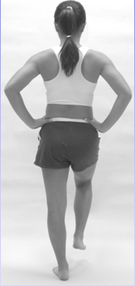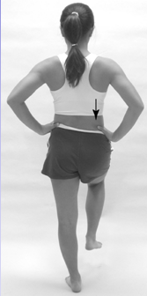

Renne’s Test
- This test is performed to detect tightness in the Tensor Fascia Latae
- Have the athlete stand with their full weight on the affected leg
- While standing on that leg, have them bend their knee to ~30-40° of flexion
- A positive sign would present with pain felt on their lateral femoral condyle

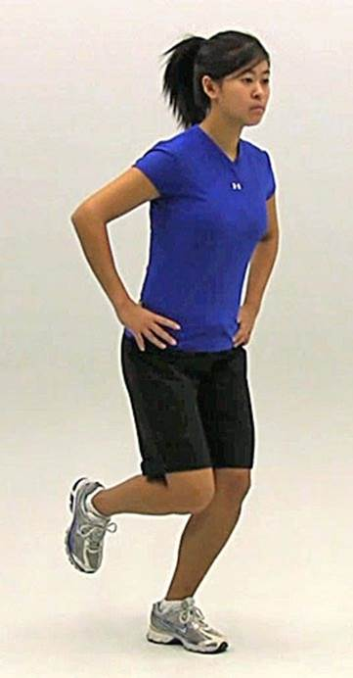
Piriformis Test
- This test is performed to determine tightness of the piriformis muscle
- Have the athlete lay on their unaffected side near the edge of a table
- Flex their injured hip to 60° and flex their knee about 90°
- Place one hand on their hip to stabilize it and the other on their knee of the affected side
- Apply downward pressure to the knee
- A positive sign would present with pain felt in the muscle

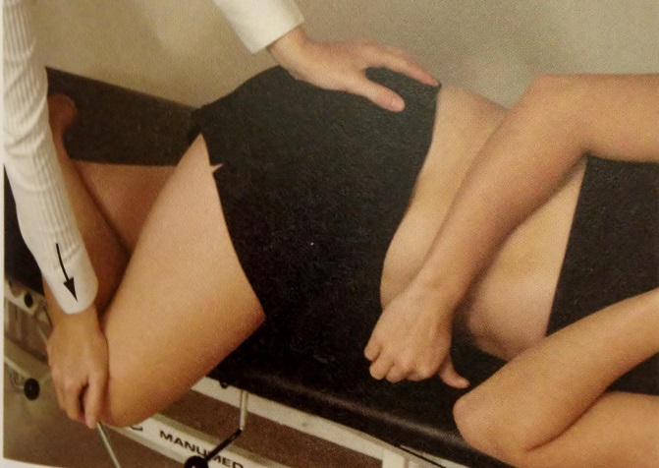

Ely’s Test
- This test is performed to determine tightness in the Rectus Femoris
- Have the athlete lay prone on the table
- Grab the ankle on the affected side and passively flex it
- A positive sign would be indicated by the hip on that side flexing

