Special Tests of the Ankle & Lower Leg

Percussion Test
- This test is performed to evaluate a possible fracture to the calcaneus, talus or distal tibia
- Have the athlete lie supine (on their back) or sit on a table with their injured foot extended over the edge of a table
- Grasp their lower leg with one hand to stabilize it
- With the heel of your other hand, gently strike the bottom of the athlete’s heel
- A positive test will result in pain that is caused by a vibratory force that resonates within the fracture

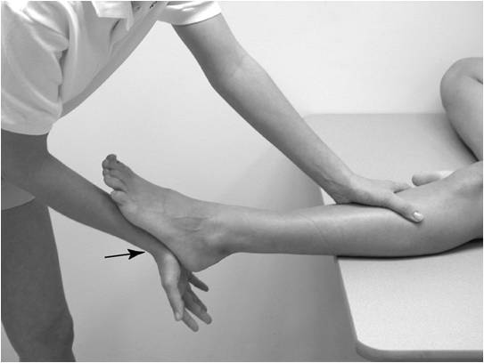

Compression Test
- This test is performed to evaluate a possible fracture of the tibia or fibula
- Have the athlete lie supine or sit on a table with their injured leg extended
- Grasp their lower leg above and below the suspected fracture site
- Squeeze their leg with your hands
- An increase in pain over the area that is point tender may be a positive sign for a fracture

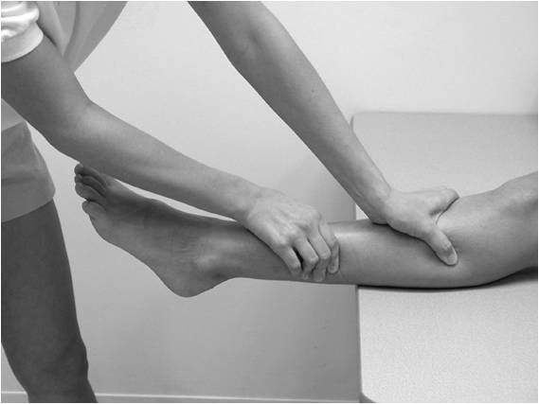

Thompson Squeeze Test
- This test is performed to evaluate the lower leg for a possible achilles tendon rupture
- Have the athlete lie prone (on their stomach) with the foot of the injured achilles over the edge of the table
- Grasp their calf muscles with one or both hands
- Squeeze their calf
- A positive sign would be that the foot does not plantar flex, indicating that they have torn their achilles tendon

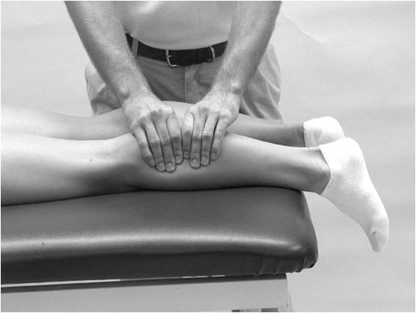

Homan’s Test
- This is a test that is performed to check for deep vein thrombophlebitis (inflammation of veins)
- Have the athlete lie supine on a table with their knee fully extended
- Grasp their leg with one hand and raise it slightly off the table
- With your other hand, passively dorsiflex their foot to stretch their calf muscles
- A positive sign is pain in their calf, and they should be referred to a physician immediately

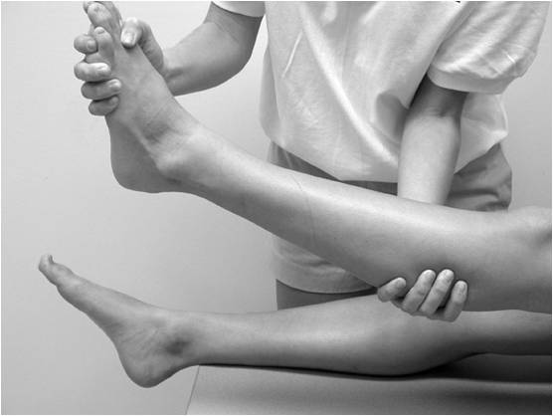

Anterior Drawer Test
- This test is performed to determine damage to the anterior talofibular ligament
- Have the athlete sit on a table with their injured leg hanging over the edge
- Place one hand behind the calcaneus and the other around the tibia and fibula
- Gently pull the foot forward and push the lower leg backward
- A positive test occurs when foot slides forward and/or makes a clunking sound as it reaches the end point

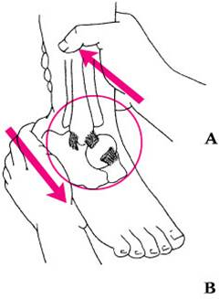
Talar Tilt Test
- This test is performed to determine the extent of inversion or eversion injuries
- Have the athlete lie supine or sit on a table with their injured ankle extended over the edge
- Grasp their lower leg with one hand to stabilize it
- Grasp their heel with your other hand
- Passively invert/evert their ankle
- A positive test would result in laxity (excess motion/looseness) and pain
  - Inversion – Indicates an injury to the calcaneofibular ligament
  - Eversion – Indicates an injury to the deltoid ligament

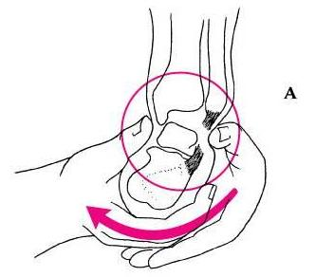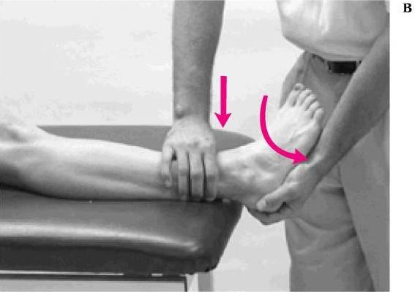

Kleiger’s Test
- This test is performed to determine the extent of an injury to the deltoid ligament primarily, but also may be used to evaluate the anterior/posterior tibiofibular ligaments
- Have the athlete lie supine or sit on a table with their injured ankle extended over the edge
- Grasp their lower leg with one hand to stabilize it
- Grasp their foot and rotate it laterally
- A positive test would result in pain and laxity

