Special Tests for the Wrist and Hand

Valgus and Varus Stress Test

Structure(s) being tested:
Ligaments connecting the carpal bones (collateral) in the hand and between each phalange

How to perform the test:
The trainer pushes the lateral side of the athlete’s hand, causing it to bend at the wrist toward the medial side. For the medial side, the trainer pushes the medial side of the athlete’s hand so it bends at the wrist toward the lateral side.
Wrist Phalanges
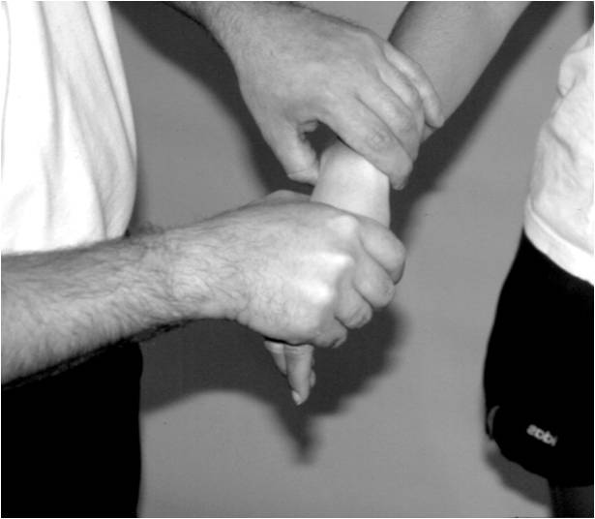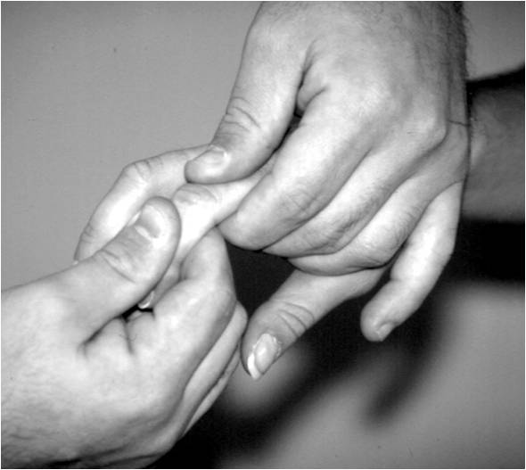

Positive sign/symptom:
Increased pain or instability with any of these tests usually indicates a ligament sprain.

Finklestein’s Test
Structure(s) being tested:
De Quervain’s Disease

How to perform the test:
The patient makes a fist with the thumb inside the fingers. The examiner stabilizes the forearm and deviates the wrist toward the ulnar side.

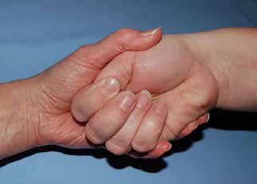

Positive sign/symptom:
Indicated by pain over the abductor pollicis longus and extensor pollicis brevis tendons at the wrist and is indicative of a tensynovitis in these two tendons. Because this test can cause discomfort in normal individuals it should be performed on both sides to see if there is a difference.

Phalen’s Test
Structure(s) being tested:
Carpal tunnel syndrome

How to perform the test:
The athlete is instructed to flex both wrists as far as possible and press them together. This position is held approximately for one minute.

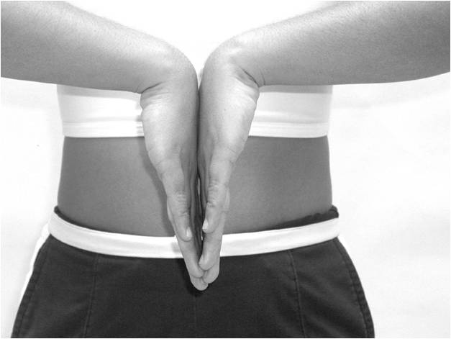

Positive sign/symptom:
If this test is positive, pain will be produced of the carpal tunnel.
Allen’s test
Structure(s) being tested:
To determine the function of the radial and ulnar arteries supplying the hand

How to perform the test:
The athlete is instructed to squeeze the hand tightly into a fist. The athlete is to then open it fully 3 to 4 times. While the athlete is holding the last fist the trainer places firm pressure over each artery. The athlete then opens their hand , the palm should be blanched (pale white). One of the arteries is then released and if normal , the hand will instantly become red, the process is repeated with the other artery.

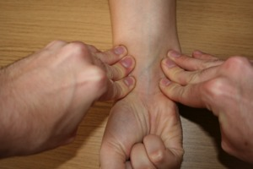

Positive sign/symptom:
Failure of color to quickly return to the palm shows evidence of poor circulation to the hand.

Tinel’s Sign (Wrist)
Structure(s) being tested:
This is a test for carpal tunnel syndrome.

How to perform the test:
Locate the transverse carpal ligament.
With one finger, tap the area over the ligament.

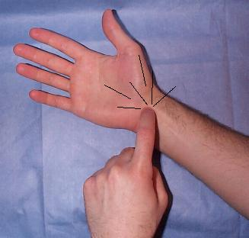

Positive sign/symptom:
A positive test will result in tingling or parasthesia over the thumb, index finger, middle finger and the lateral half of the ring finger.

