Special Tests for the Elbow
Tinel’s Sign
Structure(s) being tested:
Ulnar nerve compromise

How to perform the test:
The athlete is seated with his/her elbow in slight flexion. The trainer stands and grasps the athlete’s wrist, and with the other hand, taps (with index finger) the ulnar notch between the olecranon process and the medial epicondyle.

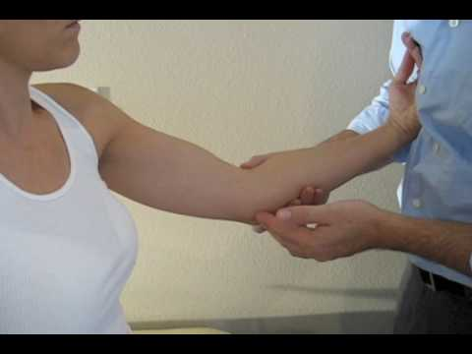

Positive sign/symptom:
When the athlete complains of a tingling sensation along the forearm, hand, and fingers.

Cozen’s Test
Structure(s) being tested:
Extensor muscle origins at the lateral epicondyle (Tennis Elbow)

How to perform the test:
The patient’s elbow is stabilized by the examiner’s thumb, which rests on the patient’s lateral epicondyle. The patient is then asked to make a fist, pronate the forearm, and radially deviate and extend the wrist while the examiner resists the motion.

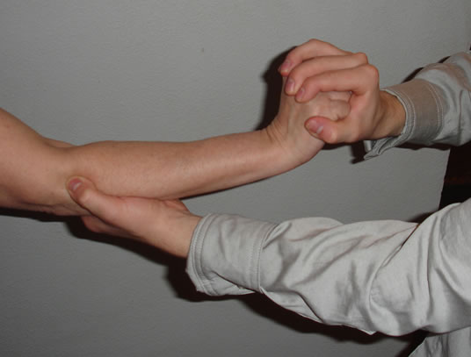

Positive sign/symptom:
Indicated by a sudden severe pain in the area of the lateral epicondyle of the humerus. The epicondyle may be palpated to indicate the origin of the pain.

Pronator Teres Syndrome Test
Structure(s) being tested:
Median Nerve compression

How to perform the test:
The athlete is in a seated position with their elbow flexed to 90°. Grasp their hand as if you were shaking it. Resist forearm pronation as the elbow is extended.

Positive sign/symptoms:
Tingling or parasthesia in the forearm and hand would indicate a positive test.

Valgus and Varus Stress Tests
Structure(s) being tested:
Sprain of the medial collateral ligament and Varus stress tests are used to check for sprains or instability of the lateral collateral ligament

How to perform the test:
Trainer grasps the athlete’s wrist and extends the arm in an anatomical position. And places the other hand over either the lateral or medial epicondyle. The hand that is over the epicondyle acts as a fulcrum and the other hand attempts to move the forearm. In applying stress the trainer should notice whether there is laxity or gapping of the ligament.
Varus Valgus
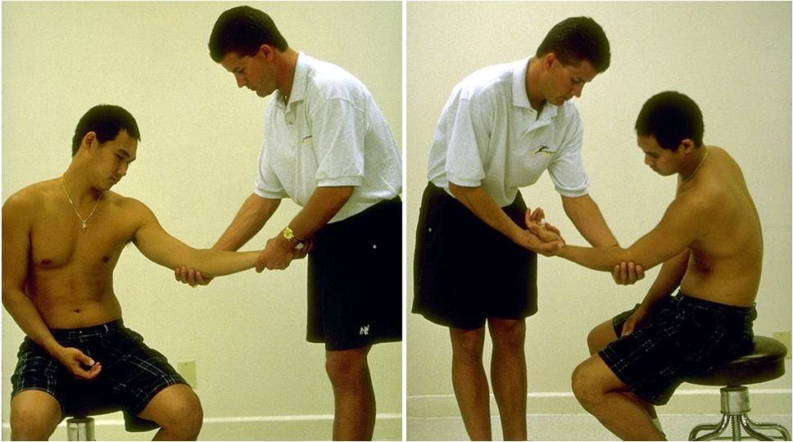

Positive sign/symptom:
If the athlete complains of severe pain, point tenderness to the ligament or laxity confirms a sprain.

Medial Epicondylitis Test
Structure(s) being tested:
Flexor muscles at the medial epicondyle (Golfer’s elbow)

How to perform the test:
Evaluator stands in front of patient.
Place one hand on their elbow with your thumb over the medial epicondyle.
Supinate their forearm and extend their elbow and wrist.

Positive sign/symptom:
A positive sign is indicated by pain over the medial epicondyle

