Special Tests for Shoulder Injuries

Glenohumeral Instability Tests

Load & Shift Test
- Have the person sit with their arm resting on their thigh
- Stand behind them with one hand stabilizing their shoulder
- With the other hand, grasp the head of the humerus with your thumb on the posterior side and fingers over the anterior side
- Press the humerus into the glenoid fossa and then apply an anterior or posterior force and notice the translation
- Movement of up to 25% of the size head of the humerus is considered normal
  - 25-50% is considered a grade I dislocation
  - Over 50% translation with the humerus returning to its normal position is considered a grade II
  - Grade III is when the humerus doesn’t return to normal

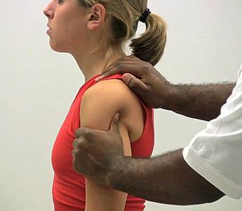

Clunk Test
This is a test for a glenoid labrum tear

- Have the person lay on their back
- Place one hand on the posterior side of their shoulder over the head of the humerus
- Hold their humerus with your other hand just above the elbow
- Fully abduct their arm over their head
- Push anteriorly with the hand under the shoulder while the other hand externally rotates the humerus
- Circumduct their arm
- A positive test is indicated by a ‘clunk’ or grinding sensation

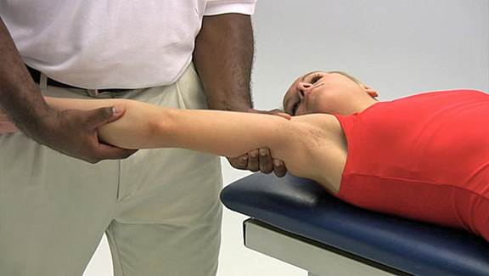

Apprehension Tests
Anterior
- Have the athlete sit on a table and stand next to their injured shoulder
- Abduct their arm to 90° and slowly externally rotate it (if you go too fast, you can actually re-dislocate their shoulder)
- A positive sign will be the look of apprehension (grimace) on their face before you reach the endpoint and it signifies an anterior instability of the GH joint

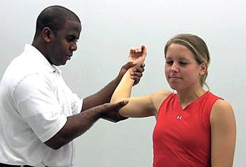
Posterior
- Have the athlete lie supine on a table
- Flex their shoulder to 90° and internally rotate it
- Gently apply pressure downward on their elbow towards their shoulder (along the humerus)
- Once again, you are looking for apprehension on their face to signify a posterior instability of the GH joint

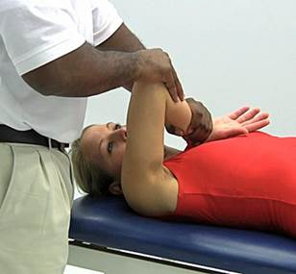

Impingement Tests

Neer’s Test
- Have the athlete sit on a table
- Grasp their wrist and forcibly flex their shoulder into an overhead position
- Pain indicates a positive test and can be indicative of an overuse injury to the supraspinatus muscle

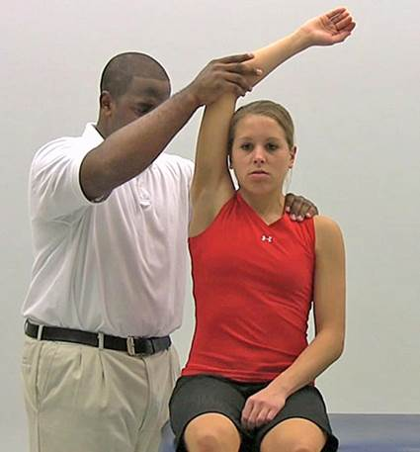
Hawkins-Kennedy Test
- Have the athlete sit on a table
- Forward flex their shoulder to 90°
- Forcibly internally rotate their shoulder
- Pain is once again a positive sign and usually indicates an injury to the supraspinatus muscle

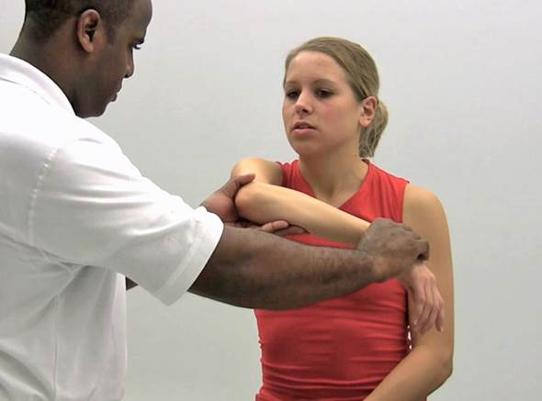

Rotator Cuff Injury Tests

Drop-Arm Test
- The athlete can either be sitting or standing
- Abduct their shoulder to at least 90°
- Instruct them to slowly lower their arm to their side
- A positive test is indicated when they cannot lower their arm slowly (it drops) or there is severe pain

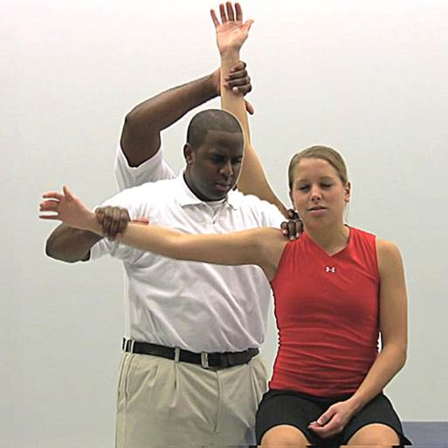

Empty Can Test
- The athlete can either be sitting or standing
- Have them flex their shoulders to 90°, horizontally abduct 30° and internally rotate them
- Gently apply a downward pressure on their arms
- A positive test is indicated by pain and/or weakness in their affected shoulder
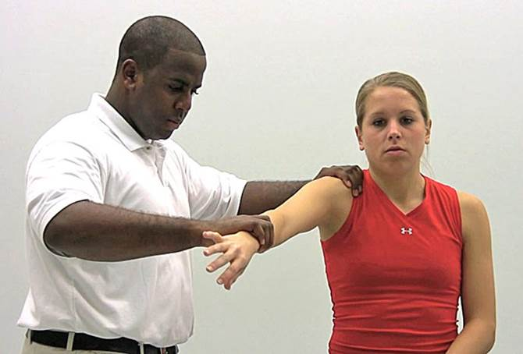
Thoracic Outlet Syndrome Tests

Roo’s Test
- Have the athlete sit on a table
- Have them abduct their arms to 90° and externally rotate them
- Have them open and close their hands (make fists) for 3 minutes
- A positive test is indicated by a loss of strength in their hands or a loss of sensation caused by a compression between the clavicle and 1st rib
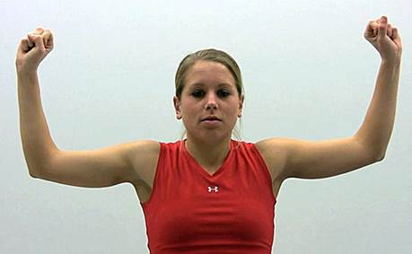
Adson’s Test
- The athlete can either be sitting or standing
- Locate their radial pulse on the affected side
- Have them rotate their head towards the test shoulder
- The athlete then leans their head back while you externally rotate their shoulder
- Instruct them to take a deep breath and hold it
- If the pulse disappears, the test is considered positive and is caused by compression of scalene muscles

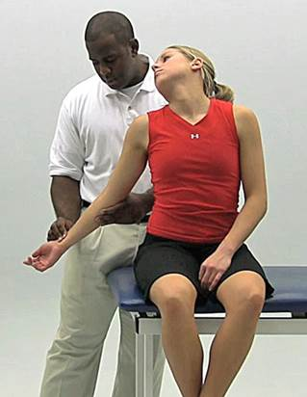
Allen Test
- Have the athlete sit on a table
- Have them abduct their arm to 90° and flex their elbow to 90° and externally rotated
- Locate their radial pulse and instruct them to turn their head away from the affected shoulder
- If their pulse disappears, the test is positive and is caused by compression of the pectoralis minor

AC Joint Test

Acromioclavicular Shear Test
- Have the athlete sit on a table
- Cup your hands over their shoulder, with one hand on their clavicle and the other on the spine of their scapula
- Squeeze the heels of your hands together
- A positive test is indicated by pain or abnormal movement of their AC joint

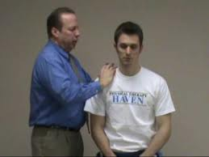

Biceps Tendon Irritation

Yergason’s Test
- Have the athlete sit on a table
- Have them flex their elbow to 90° and pronate their forearm
- Grasp their forearm with one hand and their humerus with the other
- Have the athlete supinate against resistance while also pulling down on their humerus
- The test is positive if pain is felt in the region of the bicipital groove

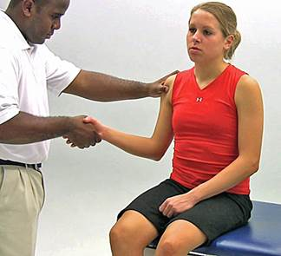
Speed’s Test
- Have the athlete sit on a table
- The athlete’s elbow should be extended and their forearm supinated
- Apply resistance as the athlete forward flexes their humerus to 60°
- The test is positive if pain is felt in the region on the bicipital groove
