Shoulder Spica

1. Start with a 4” Double ace wrap and stand facing the individual who will be wrapped

2. Wrap elastic bandage around top of the bicep two times, creating an anchor. Pull moderately tight but do not take the stretch out of the bandage.
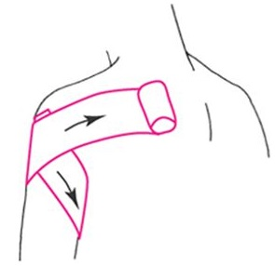

3. Wrap underneath the armpit, over the top of the shoulder and across the chest, pulling tightly. Follow the wrap underneath the unaffected armpit and across the back and pull tightly over the shoulder, loop underneath the affected armpit and over the shoulder again, back across the chest.

Overlap the bandage at least one-half width of the previous pattern. Repeat the pattern until the elastic bandage runs out.

Tape the finished end of the elastic wrap and follow the pattern back. Tape around the anchor on the arm for an extra support wrap. The spica should resemble a figure-8 pattern.

