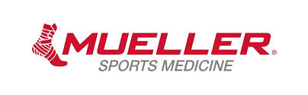
Thank you Mueller & Henry Schein!
The Oral Practical is sponsored by Mueller & Henry Schein. This year expendables won’t be donated until we get a continuing contract in place for supplies.
OP Supply List
10 rolls, 1 1/2” Mueller M Tape
4 rolls, 1" Mueller M Tape
2 rolls each, 2” & 3” Mueller Stretch M Tape
Mueller & Henry Schein Expendables
5 rolls, Mueller M Wrap
3 rolls each, 3", 2" Mueller Tear Light
1 each, 2", 4", & 6” single length Mueller Elastic Bandage
1 each, 4", & 6” double length Mueller Elastic Bandage
15 Heel-n-Lace Pads
1 Mueller Bandage Scissors
1 Mueller M Cutter
1 can, Mueller Tuf Skin
1 Pen Light
1 SAM Splint
1 Reflex Hammer
1 Goniometer
1 set, Crutches (in room)
1 Football Helmet (in room)
1 Football Shoulder Pads (in room)
1 Body Fat Calipers (fat-o-meter)
1 Tape measure
1 bottle, Massage Lotion
1 CPR Manikin & face shields (8)
Padding Materials
15 Tongue Depressors
1 Bag- Non-sterile gloves (Latex Free)
1 Bottle, Saline Water
Pen and Paper
6 sheets, Adhesive Dots for anatomical landmarks
1 Sphygmomanometer
1 Triangle Bandage
1 Stethoscope
1 Elastic Band
1 Clipboard
1 Timer

