- Pre Wrap | 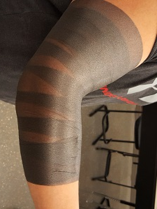 | Start the pre wrap about halfway up the humerus and overlap it as you make your way down to the halfway point of the ulna and radius
- Anchor Strips | 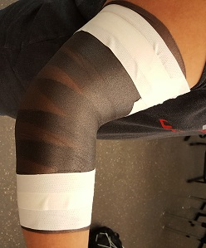 | Place two anchor strips at the top and two at the bottom, overlap each strip at least halfway.
- Crossing Strips | 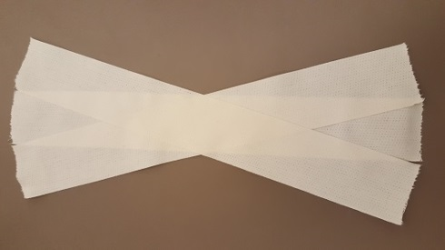 | Measure out a strip of tape that extend beyond each anchor. Measure out 2 more strips of the same length and cross them
4. Apply Crossing Strips | 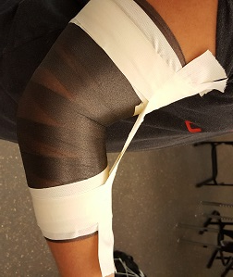 | Place crossing strips above the top anchor, and place an anchor over it. Apply tension and anchor the distal end of the crossing strips.
5. Anchor Crossing  Strips | 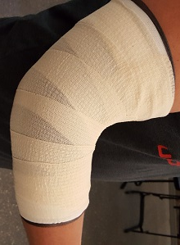 | Fold the ends of the crossing strips over the anchors and apply elastic tape over the entire elbow

