- Anchor Strip | 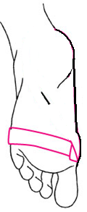 | After applying tape adherent to the bottom and sides of foot, place an anchor along the distal heads of the metatarsals
- Arch Support Strips | 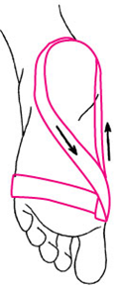 | Tear a long strip of tape into two narrow strips.  Start on the anchor on the side of the big toe  Move the tape along the inside of the foot  Circle the tape around the back of the heel  Cross the tape under the foot and return to the starting point
2b. Arch Strips Cont. | 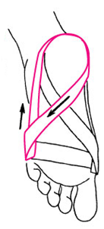 | With the other narrow strip of tape start on the anchor on the side of the pinky toe  Move the tape along the side of the foot  Circle the tape around the back of the heel  Cross the tape under the foot and return to the starting point
2c. Arch Strips and Anchor | 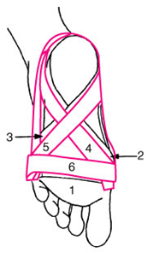 | Repeat the previous two steps at least one more time.  Apply a closing anchor over the initial anchor.
- Pre Wrap & Cover Tape |  | Finish by apply a layer of pre wrap and stretch tape around the foot

